**Aiswarya’s Visualization DATA225 Lab2**

1. **Visualizing the number of companies in top 10 cities:**

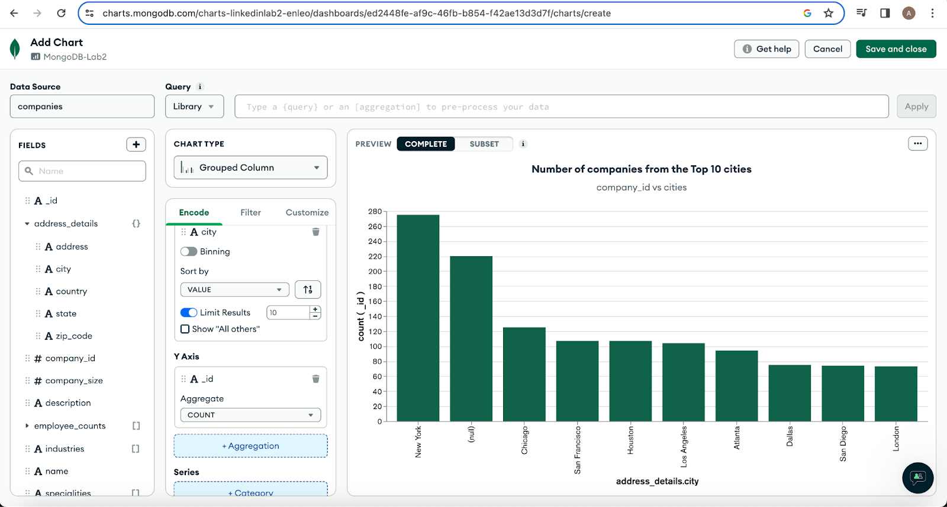

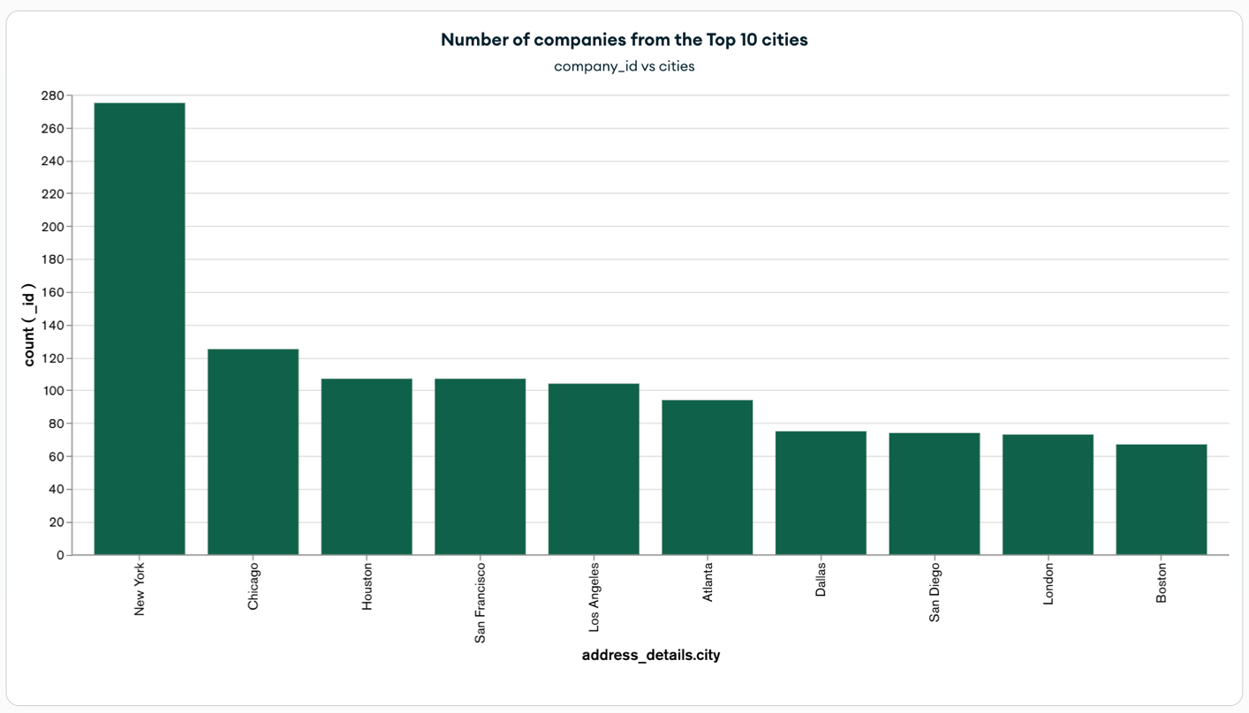

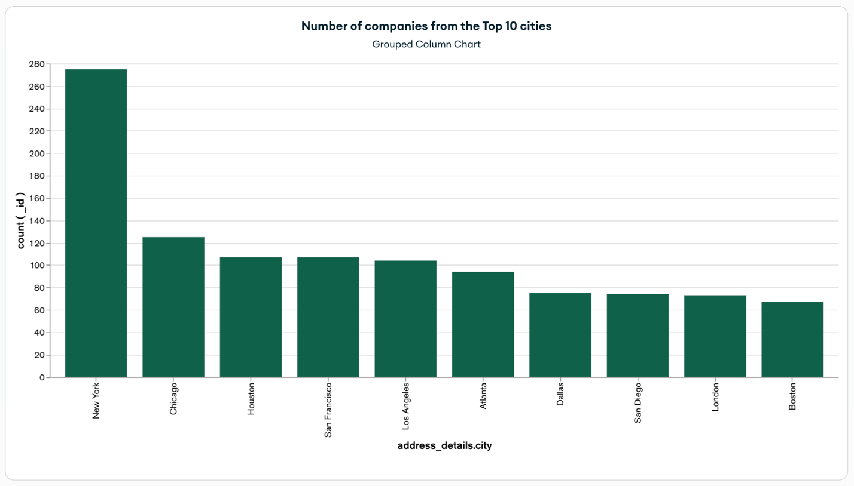

**Observation**:

* We observe the maximum number of companies in New York city with a count of 275 companies.
* X axis represents the cities (city) and Y axis represents company_id (_id)

1. **Visualizing number of jobs belong to each pay_period and their respective max_salary:**

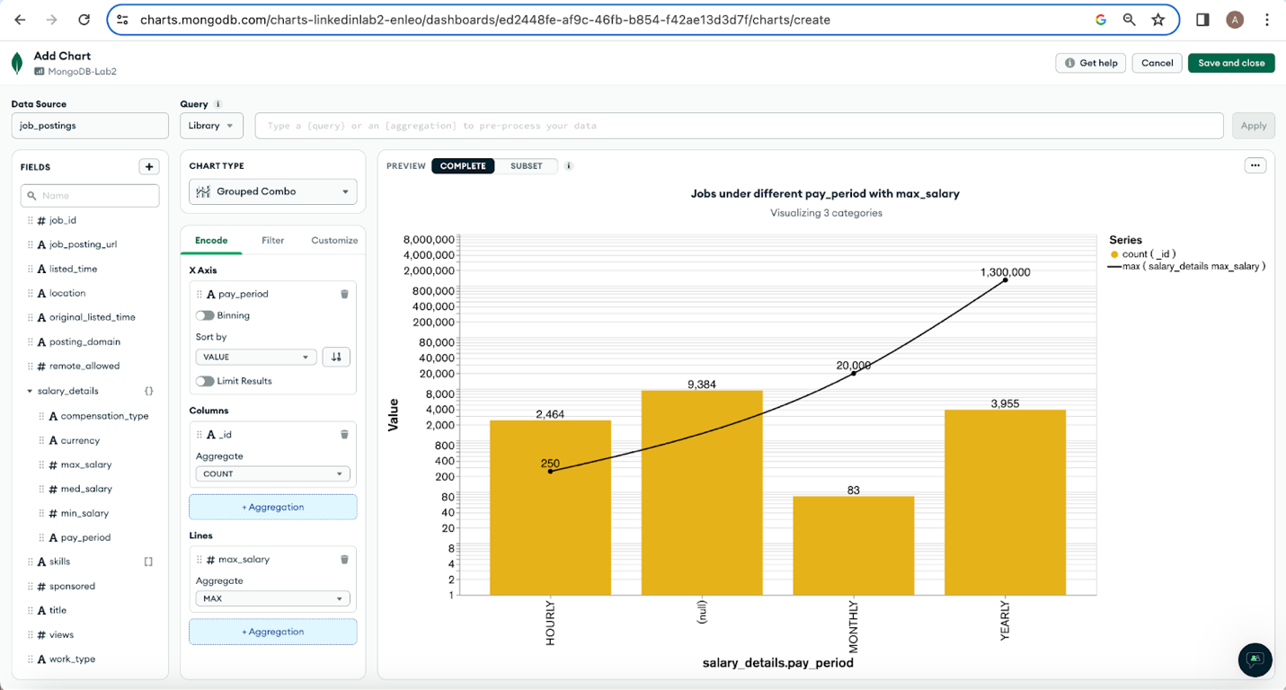

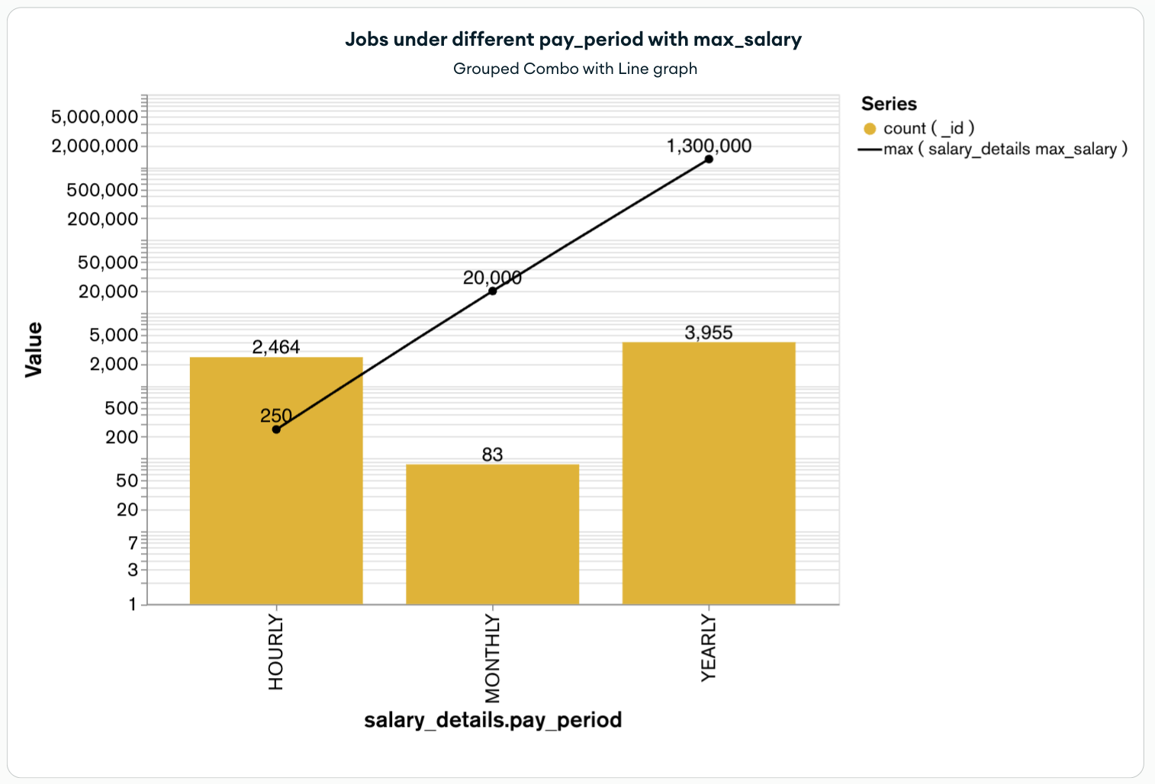

**Observation**:

* We have the maximum number of job_postings in each pay_period category along with its corresponding max_salary.
* X axis represents the pay_period and Y axis represents the Values denoting the pay_period and the max_salary. The line graph represents the max_salary.
* The least amount of job_postings are observed in the MONTHLY pay_period category and its corresponding max_salary of $20,000. The highest number of job_postings were for Yearly pay_period and its corresponding max_salary is $1,300,000.

1. **Visualizing the spread of the Skills:**

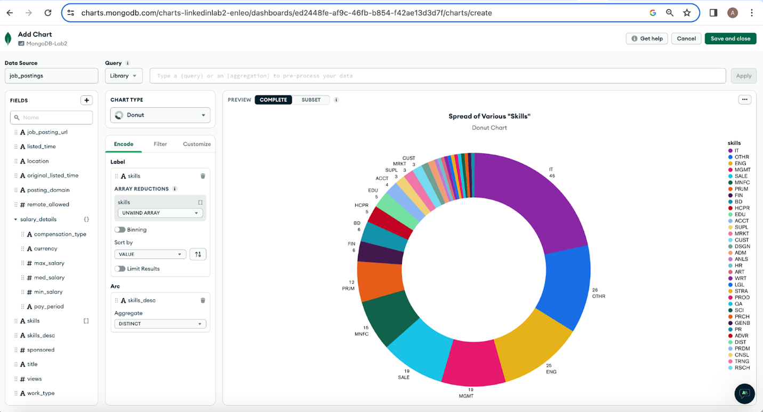

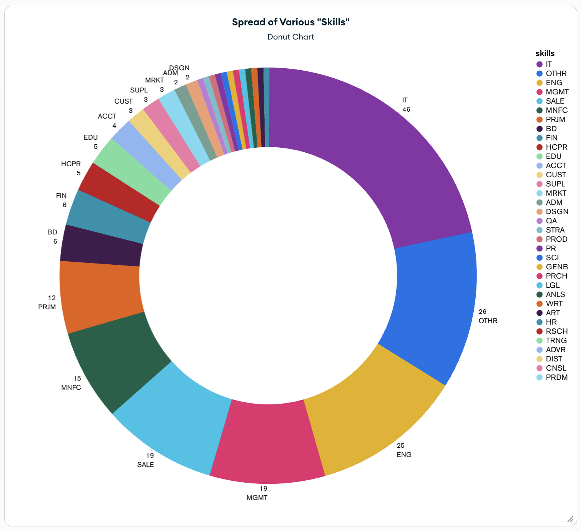

**Observation:**

* Visualizing the distribution of the skills along with its data points. Here the majority of the job_postings requires IT skills.

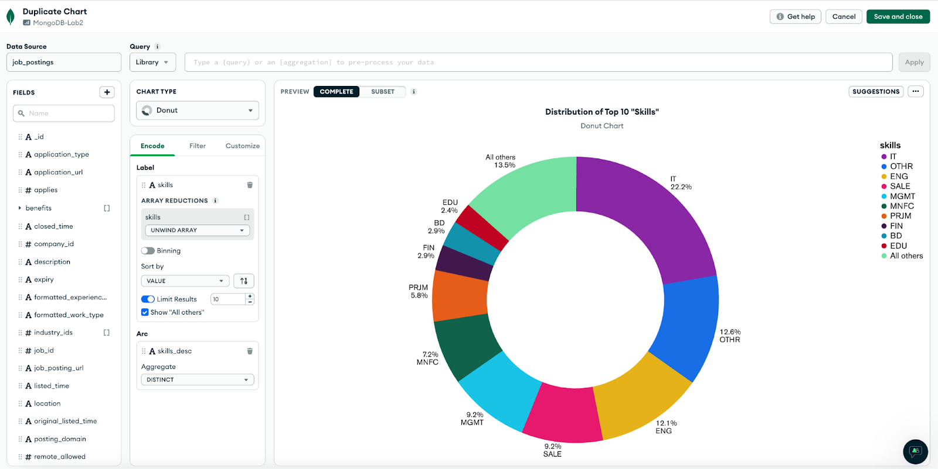

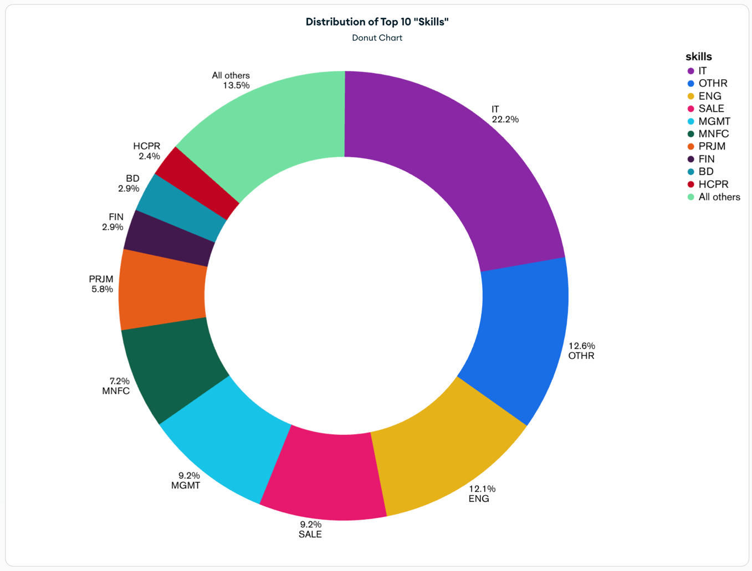

**Observation:**

* Visualizing the distribution of top 10 skills along with the data points percentage. Here the majority of the job_postings requires IT skills having 22.2 %.

1. **Geo Choropleth View:**

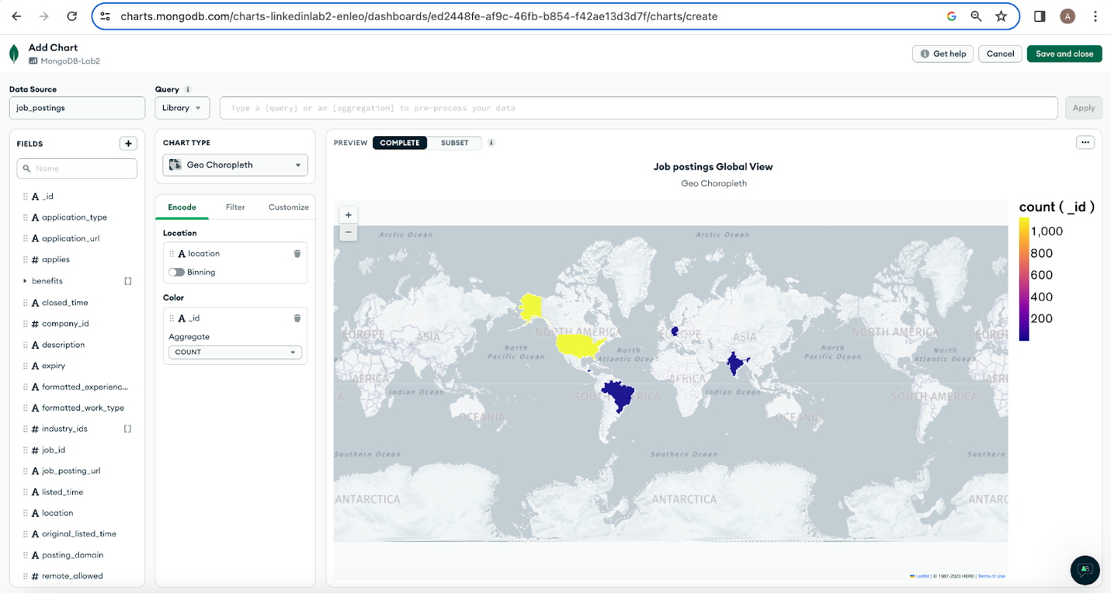

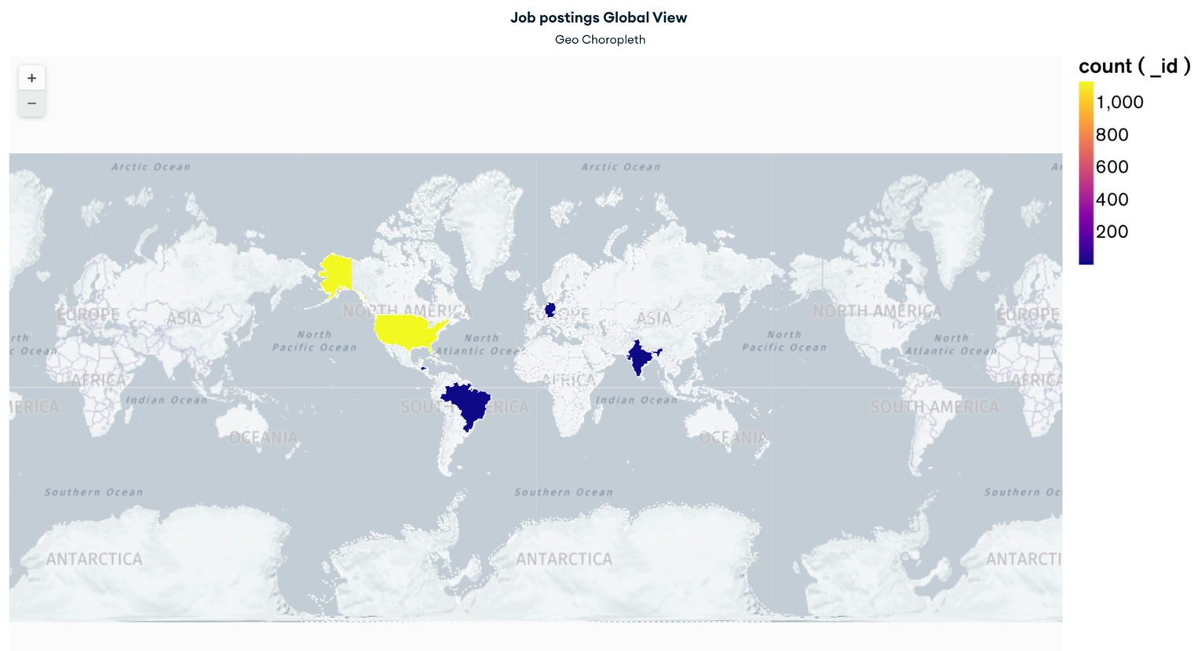

**Observation:**

* Here the Geo Choropleth explains that the maximum job postings are from the country United States (North American continent) and the least count of jobs are from the countries Honduras (Central American Continent), Brazil (South American Continent), Germany (European Continent) and India (Asian continent)

1. **Experience Level and Work Type:**

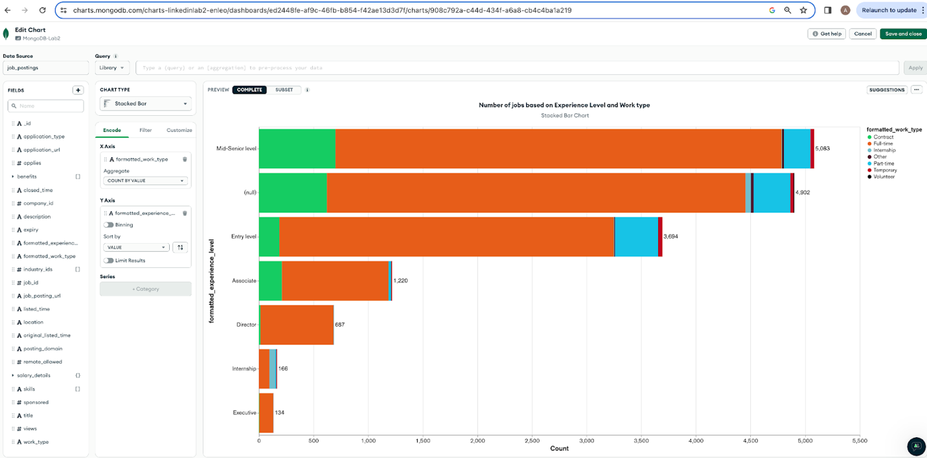

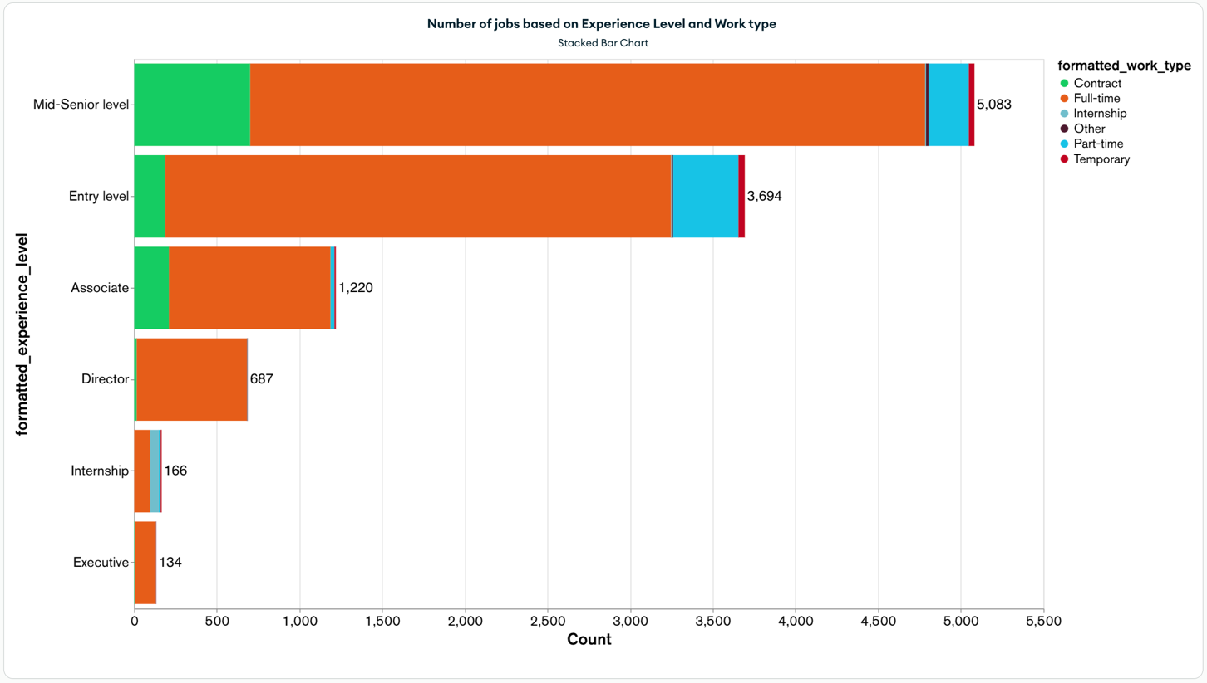

**Observation:**

* Here formatted_experience_level and the formatted_work_type can be observed. Almost across all the experience level categories the majority of work type is of Full-Time. Very minimal counts of ‘Contract’ positions can be observed in the Director level experience category. For the internship experience level, work types of Full-Time are more than the work types of internship.
* X axis represents the count of formatted_work_type and Y-axis has formatted_expereince_level values.

1. **Word Cloud:**

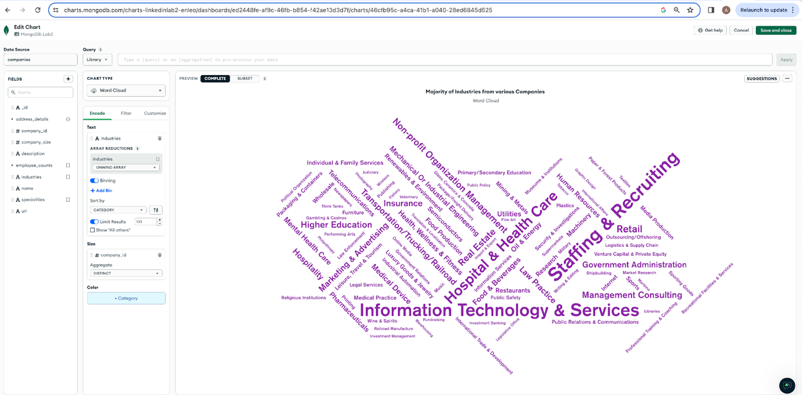

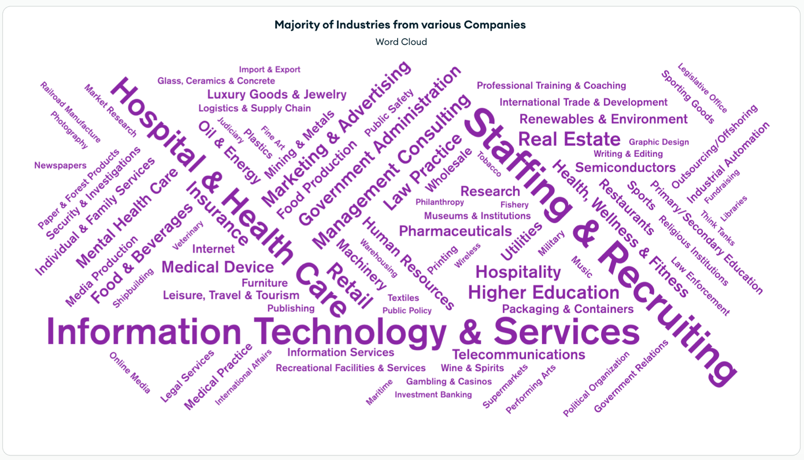

**Observation:**

* + Here the Word Cloud feature is applied to understand the Industries spread across various companies. We observe the Top 3 major industries from various companies are “Information Technology & Services”, “Staffing & Recruiting” and “Hospital & Health Care”.